Report for Lab Assignment 5

Questions:

Spark and Smartphone/Watch Application

Implement a smart application with big data analytics related to your project showing the collaboration between Spark and Smart Apps. Note: For the big data analytics part, you can use either SparkR or Spark MLlib.

Descriptions:

Using sparkR Mlib run k means analysis and sent notifications to watch

Screenshot:

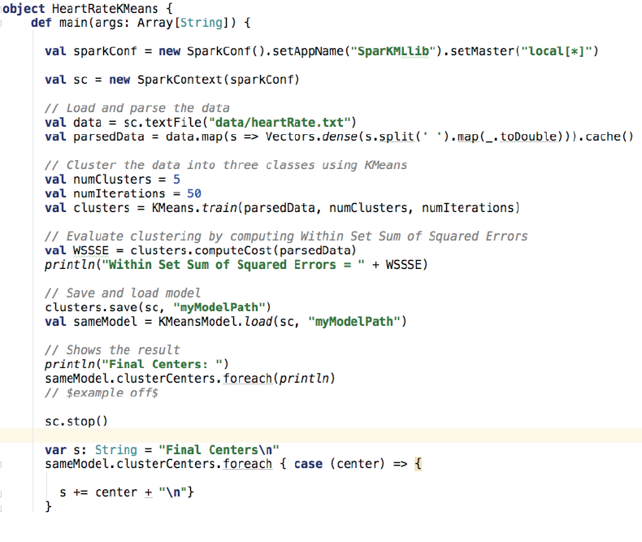

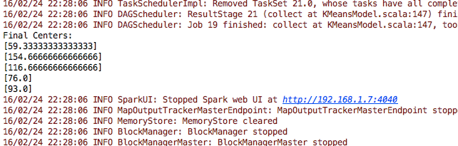

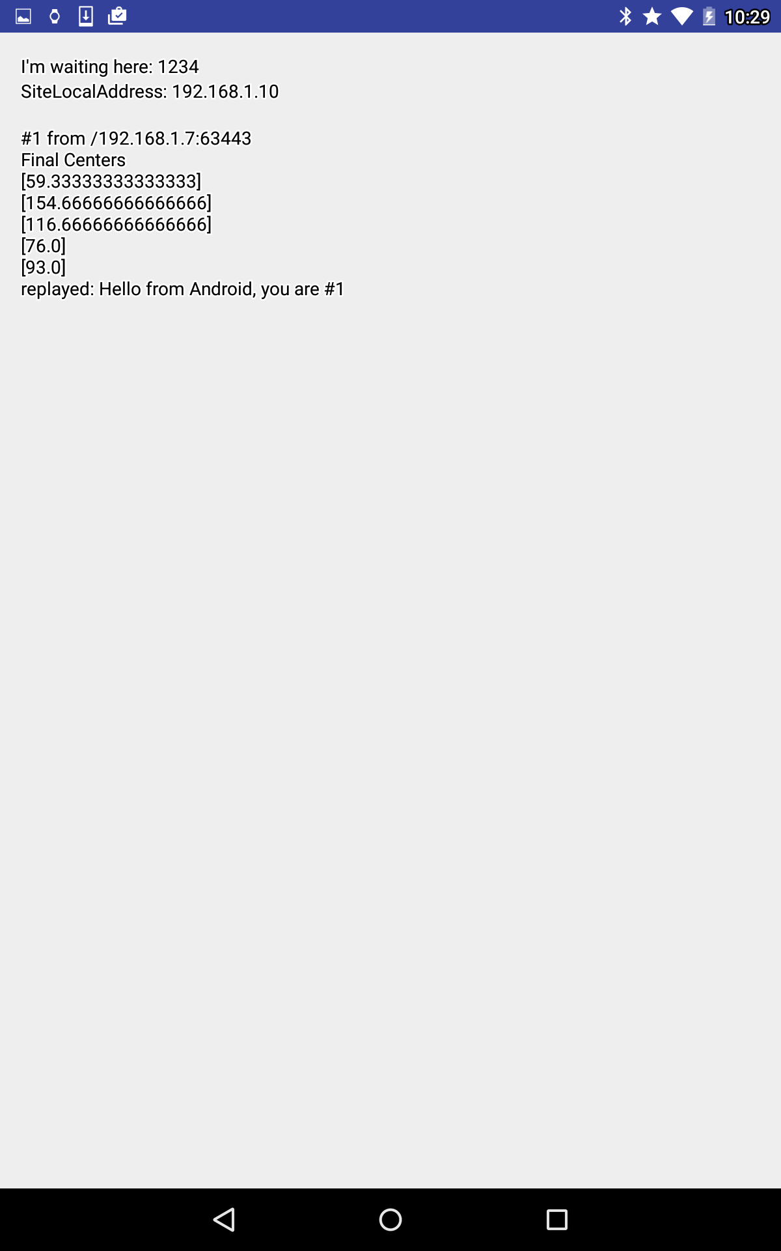

Questions:

SparkR – Extra Credit

Install Spark and Configure SparkR. Execute Word Count and K-Means Clustering algorithms using your own data (relevant to your project) with SparkR. Write a report including your algorithms and result screenshots. Modify the K-Means SparkR implementation for K-Medoids algorithm. Reference: <https://amplab-> extras.github.io/SparkR-pkg/

sparkR code: ./sparkR kmeans.R local “Heart rate sample data.txt” 3 9

Descriptions:

By using the specific K-means.R package and run it in sparkR, I calculated the k means for sample heart rate.

Screenshot/sparkR output file:

Finished iteration (delta = 86832 )

[1] 9

There were 50 or more warnings (use warnings() to see the first 50)

Final centers:

123

61

125

55

76

73

89

137

139

101

99

84

110

90

95

55

72

114

52

54

124

53

71

108

102

104

103

79

94

51

59

87

105

133

123

61

125

55

76

73

89

137

139

101

99

84

110

90

95

55

72

114

52

54

124

53

71

108

102

104

103

79

94

51

59

87

105

133

123

61

125

55

76

73

89

137

139

101

99

84

110

90

95

55

72

114

52

54

124

53

71

108

102

104

103

79

94

51

59

87

105

133

[,1] [,2] [,3] [,4] [,5] [,6] [,7] [,8] [,9] [,10] [,11] [,12]

[1,] 1452 4800 1728 6348 1875 2352 432 3888 4332 0 12 867

[2,] 4563 1587 5043 2523 192 363 75 8427 9075 867 675 0

[3,] 1728 4332 2028 5808 1587 2028 300 4332 4800 12 0 675

[4,] 1200 5292 1452 6912 2187 2700 588 3468 3888 12 48 1083

[5,] 972 5808 1200 7500 2523 3072 768 3072 3468 48 108 1323

[6,] 15552 300 16428 48 1875 1452 4332 22188 23232 7500 6912 3267

[7,] 3888 2028 4332 3072 363 588 12 7500 8112 588 432 27

[8,] 2523 3267 2883 4563 972 1323 75 5547 6075 147 75 300

[9,] 15123 243 15987 27 1728 1323 4107 21675 22707 7203 6627 3072

[10,] 768 18252 588 21168 11907 13068 7500 12 0 4332 4800 9075

[11,] 3 11907 3 14283 6912 7803 3675 507 675 1587 1875 4800

[12,] 14700 192 15552 12 1587 1200 3888 21168 22188 6912 6348 2883

[13,] 12288 12 13068 48 867 588 2700 18252 19200 5292 4800 1875

[14,] 1083 5547 1323 7203 2352 2883 675 3267 3675 27 75 1200

[15,] 13872 108 14700 0 1323 972 3468 20172 21168 6348 5808 2523

[16,] 3468 2352 3888 3468 507 768 0 6912 7500 432 300 75

[17,] 7803 363 8427 867 48 3 867 12675 13467 2523 2187 432

[18,] 8112 300 8748 768 75 12 972 13068 13872 2700 2352 507

[19,] 507 7203 675 9075 3468 4107 1323 2187 2523 243 363 2028

[20,] 588 17328 432 20172 11163 12288 6912 0 12 3888 4332 8427

[21,] 0 11532 12 13872 6627 7500 3468 588 768 1452 1728 4563

[22,] 6627 675 7203 1323 0 27 507 11163 11907 1875 1587 192

[23,] 3267 2523 3675 3675 588 867 3 6627 7203 363 243 108

[24,] 243 8427 363 10443 4332 5043 1875 1587 1875 507 675 2700

[25,] 675 6627 867 8427 3072 3675 1083 2523 2883 147 243 1728

[26,] 11532 0 12288 108 675 432 2352 17328 18252 4800 4332 1587

[27,] 13872 108 14700 0 1323 972 3468 20172 21168 6348 5808 2523

[28,] 5808 972 6348 1728 27 108 300 10092 10800 1452 1200 75

[29,] 2352 3468 2700 4800 1083 1452 108 5292 5808 108 48 363

[30,] 12 12288 0 14700 7203 8112 3888 432 588 1728 2028 5043

[31,] 7500 432 8112 972 27 0 768 12288 13068 2352 2028 363

[32,] 300 15552 192 18252 9747 10800 5808 48 108 3072 3468 7203

[33,] 14283 147 15123 3 1452 1083 3675 20667 21675 6627 6075 2700

[34,] 1323 5043 1587 6627 2028 2523 507 3675 4107 3 27 972

[,13] [,14] [,15] [,16] [,17] [,18] [,19] [,20] [,21] [,22] [,23] [,24]

[1,] 243 363 108 6348 2523 507 7203 6627 1587 6912 2700 147

[2,] 2028 108 363 2523 432 2700 3072 2700 4800 2883 507 1728

[3,] 363 243 48 5808 2187 675 6627 6075 1875 6348 2352 243

[4,] 147 507 192 6912 2883 363 7803 7203 1323 7500 3072 75

[5,] 75 675 300 7500 3267 243 8427 7803 1083 8112 3468 27

[6,] 10443 4563 5808 48 1323 11907 3 27 15987 12 1200 9747

[7,] 1587 27 192 3072 675 2187 3675 3267 4107 3468 768 1323

[8,] 768 48 3 4563 1452 1200 5292 4800 2700 5043 1587 588

[9,] 10092 4332 5547 27 1200 11532 0 12 15552 3 1083 9408

[10,] 2523 7203 5808 21168 13467 1875 22707 21675 675 22188 13872 2883

[11,] 588 3468 2523 14283 8112 300 15552 14700 0 15123 8427 768

[12,] 9747 4107 5292 12 1083 11163 3 3 15123 0 972 9075

[13,] 7803 2883 3888 48 507 9075 147 75 12675 108 432 7203

[14,] 108 588 243 7203 3072 300 8112 7500 1200 7803 3267 48

[15,] 9075 3675 4800 0 867 10443 27 3 14283 12 768 8427

[16,] 1323 3 108 3468 867 1875 4107 3675 3675 3888 972 1083

[17,] 4332 972 1587 867 0 5292 1200 972 8112 1083 3 3888

[18,] 4563 1083 1728 768 3 5547 1083 867 8427 972 0 4107

[19,] 0 1200 675 9075 4332 48 10092 9408 588 9747 4563 12

[20,] 2187 6627 5292 20172 12675 1587 21675 20667 507 21168 13068 2523

[21,] 507 3267 2352 13872 7803 243 15123 14283 3 14700 8112 675

[22,] 3468 588 1083 1323 48 4332 1728 1452 6912 1587 75 3072

[23,] 1200 0 75 3675 972 1728 4332 3888 3468 4107 1083 972

[24,] 48 1728 1083 10443 5292 0 11532 10800 300 11163 5547 108

[25,] 12 972 507 8427 3888 108 9408 8748 768 9075 4107 0

[26,] 7203 2523 3468 108 363 8427 243 147 11907 192 300 6627

[27,] 9075 3675 4800 0 867 10443 27 3 14283 12 768 8427

[28,] 2883 363 768 1728 147 3675 2187 1875 6075 2028 192 2523

[29,] 675 75 0 4800 1587 1083 5547 5043 2523 5292 1728 507

[30,] 675 3675 2700 14700 8427 363 15987 15123 3 15552 8748 867

[31,] 4107 867 1452 972 3 5043 1323 1083 7803 1200 12 3675

[32,] 1587 5547 4332 18252 11163 1083 19683 18723 243 19200 11532 1875

[33,] 9408 3888 5043 3 972 10800 12 0 14700 3 867 8748

[34,] 192 432 147 6627 2700 432 7500 6912 1452 7203 2883 108

[,25] [,26] [,27] [,28] [,29] [,30] [,31] [,32] [,33] [,34]

[1,] 3 27 12 1452 147 7500 5292 588 48 3072

[2,] 972 1200 1083 75 300 3267 1875 27 1323 7203

[3,] 27 75 48 1200 75 6912 4800 432 108 3468

[4,] 3 3 0 1728 243 8112 5808 768 12 2700

[5,] 27 3 12 2028 363 8748 6348 972 0 2352

[6,] 7803 8427 8112 2352 5547 0 192 3888 8748 20172

[7,] 675 867 768 192 147 3888 2352 0 972 6348

[8,] 192 300 243 675 0 5547 3675 147 363 4563

[9,] 7500 8112 7803 2187 5292 3 147 3675 8427 19683

[10,] 4107 3675 3888 10800 6075 23232 19200 8112 3468 108

[11,] 1452 1200 1323 6075 2700 15987 12675 4107 1083 243

[12,] 7203 7803 7500 2028 5043 12 108 3468 8112 19200

[13,] 5547 6075 5808 1200 3675 192 0 2352 6348 16428

[14,] 12 0 3 1875 300 8427 6075 867 3 2523

[15,] 6627 7203 6912 1728 4563 48 48 3072 7500 18252

[16,] 507 675 588 300 75 4332 2700 12 768 5808

[17,] 2700 3072 2883 147 1452 1323 507 675 3267 11163

[18,] 2883 3267 3072 192 1587 1200 432 768 3468 11532

[19,] 192 108 147 2883 768 10443 7803 1587 75 1587

[20,] 3675 3267 3468 10092 5547 22188 18252 7500 3072 48

[21,] 1323 1083 1200 5808 2523 15552 12288 3888 972 300

[22,] 2028 2352 2187 27 972 1875 867 363 2523 9747

[23,] 432 588 507 363 48 4563 2883 27 675 5547

[24,] 432 300 363 3675 1200 11907 9075 2187 243 1083

[25,] 108 48 75 2523 588 9747 7203 1323 27 1875

[26,] 5043 5547 5292 972 3267 300 12 2028 5808 15552

[27,] 6627 7203 6912 1728 4563 48 48 3072 7500 18252

[28,] 1587 1875 1728 0 675 2352 1200 192 2028 8748

[29,] 147 243 192 768 3 5808 3888 192 300 4332

[30,] 1587 1323 1452 6348 2883 16428 13068 4332 1200 192

[31,] 2523 2883 2700 108 1323 1452 588 588 3072 10800

[32,] 2883 2523 2700 8748 4563 20172 16428 6348 2352 0

[33,] 6912 7500 7203 1875 4800 27 75 3267 7803 18723

[34,] 0 12 3 1587 192 7803 5547 675 27 2883

16/02/23 12:50:17 INFO SparkContext: Invoking stop() from shutdown hook

16/02/23 12:50:17 INFO SparkUI: Stopped Spark web UI at http://10.151.4.221:4040

16/02/23 12:50:17 INFO MapOutputTrackerMasterEndpoint: MapOutputTrackerMasterEndpoint stopped!

16/02/23 12:50:17 INFO MemoryStore: MemoryStore cleared

16/02/23 12:50:17 INFO BlockManager: BlockManager stopped

16/02/23 12:50:17 INFO BlockManagerMaster: BlockManagerMaster stopped

16/02/23 12:50:17 INFO OutputCommitCoordinator$OutputCommitCoordinatorEndpoint: OutputCommitCoordinator stopped!

16/02/23 12:50:17 INFO SparkContext: Successfully stopped SparkContext

16/02/23 12:50:17 INFO ShutdownHookManager: Shutdown hook called

16/02/23 12:50:17 INFO ShutdownHookManager: Deleting directory /private/var/folders/qk/1jbpq9p52n9004zj72d6bz6r0000gn/T/spark-5e8ae920-7ec5-4590-b2a6-10ca630ca1f0

weis-mbp:bin whng2$